**Core java concepts**

***/*  
* Deserialization of Singleton class breaks the Singleton Pattern if***

***\* readResolve method is no used.  
* */*class** Student **implements** Serializable {  
  
 **public static** Student *student* = **new** Student();  
  
 **private** Student() {  
 }  
}

**class** Serialization_Deserialization {  
 **public static void** main(String[] args) **throws** Exception {  
 Student student = Student.*student*;  
  
 *// Serialization* ObjectOutputStream objectOutputStream = **new** ObjectOutputStream(**new** FileOutputStream(**"a.txt"**));  
 objectOutputStream.writeObject(student);  
  
 *// Deserialization* ObjectInputStream objectInputStream = **new** ObjectInputStream(**new** FileInputStream(**"a.txt"**));  
 Student studentDeserialized = (Student) objectInputStream.readObject();  
  
 System.***out***.println(**"Hash Code before serialiation: "** + student.hashCode());  
 System.***out***.println(**"Hash Code After serialiation: "** + studentDeserialized.hashCode());  
 }  
}

**OUTPUT :**

**Hash Code before serialiation: 2133927002**

**Hash Code After serialiation: 81628611**

**# We have to override readResolve method**

**class** Student **implements** Serializable {  
  
 **public static** Student *student* = **new** Student();  
  
 **private** Student() {  
 }  
  
 **public** Object readResolve() {  
 **return** *student*;  
 }  
}

**OUTPUT :**

**Hash Code before serialiation: 2133927002**

**Hash Code After serialiation: 2133927002**

**Ques ::: Whether java is fully object oriented or not?**

**Answer::** Java is not fully object oriented as it supports the use of primitive data types. SmallTalk is the language that is fully object oriented.

But with reference to the wrapper classes we can say that java is fully object oriented.

New things introduced in 1.5

1. For each loop
2. Var-arg methds
3. Autoboxing auto unboxing
4. Generics
5. Covariant return types
6. Queue
7. Annotations
8. Enum
9. Static import

***Jvm architecture***

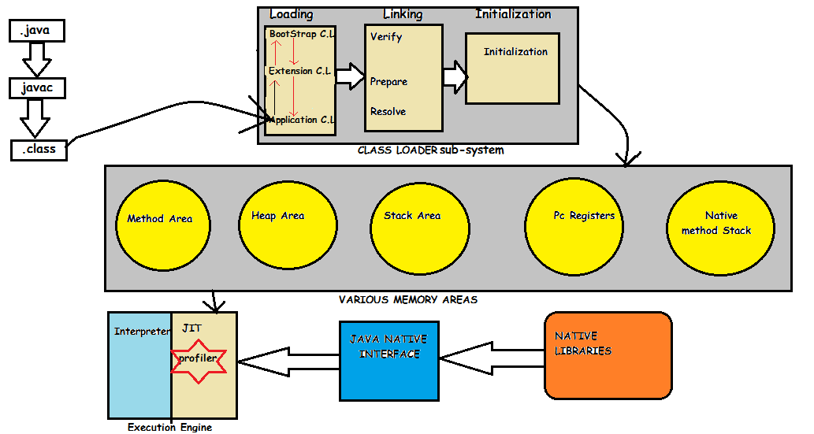

Whenever JVM is across a class, it will check whether the .class file is already loaded or not. If it is already in method area then jvm will consider that loaded class. If it is not loaded then jvm request class loader subsystem to load that particular class. then class loader subsystem hand over the request to the application C.L. App. C.L delegates the requests to extension C.L which in turn delegates the request to bootstrap C.L. then bootstrap C.L loader searches it in bootstrap class path. If it is available then it is loaded by it. If it is not available then bootstrap C.L delegates the request to extension C.L. Extension C.L searches in Extension classpath. It is available then it is loaded otherwise it delegates the request to the application C.L. Application C.L searches in Application classpath i.e, Environment variable.(This above is called Delegation-Hierarchy principle).

**Loading :** The Class loader reads the *.class* file, generate the corresponding binary data and save it in method area. For each *.class* file, JVM stores following information in method area.

* Fully qualified name of the loaded class and its immediate parent class.
* Whether *.class* file is related to Class or Interface or Enum
* Modifier, Variables and Method information etc.

After loading *.class* file, JVM creates an object of type Class to represent this file in the heap memory. Please note that this object is of type Class predefined in *java.lang* package. This Class object can be used by the programmer for getting class level information like name of class, parent name, methods and variable information etc. To get this object reference we can use *getClass()* method of [Object](https://www.geeksforgeeks.org/object-class-in-java/) class.

|  |
| --- |
| *// A Java program to demonstrate working of a Class type // object created by JVM to represent .class file in // memory.* **import** java.lang.reflect.Field; **import** java.lang.reflect.Method;  *// Java code to demonstrate use of Class object // created by JVM* **class** Test {  **public static void** main(String[] args) {  Student s1 = **new** Student();   *// Getting hold of Class object created  // by JVM.* Class c1 = s1.getClass();   *// Printing type of object using c1.* System.***out***.println(c1.getName());   *// getting all methods in an array* Method m[] = c1.getDeclaredMethods();  **for** (Method method : m)  System.***out***.println(method.getName());   *// getting all fields in an array* Field f[] = c1.getDeclaredFields();  **for** (Field field : f)  System.***out***.println(field.getName());  } }  *// A sample class whose information is fetched above using // its Class object.* **class** Student {  **private** String **name**;  **private int roll_No**;   **public** String getName() {  **return name**;  }   **public void** setName(String name) {  **this**.**name** = name;  }   **public int** getRoll_no() {  **return roll_No**;  }   **public void** setRoll_no(**int** roll_no) {  **this**.**roll_No** = roll_no;  } } |

Output:

Student

getName

setName

getRoll_no

setRoll_no

name

roll_No

**#Note : For every loaded *.class* file, only one object of Class is created.**

Student s2 = **new** Student();  
*// c2 will point to same object where   
// c1 is pointing*Class c2 = s2.getClass();  
System.***out***.println(c1 == c2); *// true*

**Linking :** Performs verification, preparation, and (optionally) resolution.

* *Verification* : It ensures the correctness of *.class* file i.e. it check whether this file is properly formatted and generated by valid compiler or not. If verification fails, we get run-time exception *java.lang.VerifyError*.
* *Preparation* : JVM allocates memory for class variables and initializing the memory to default values.
* *Resolution* : It is the process of replacing symbolic references from the type with direct references. It is done by searching into method area to locate the referenced entity.

**Initialization :** In this phase, all static variables are assigned with their values defined in the code and static block(if any). This is executed from top to bottom in a class and from parent to child in class hierarchy.

**public class Test extends Thread {**

**public static void main(String[] args) {**

**System.*out*.println(String.class.getClassLoader());// null**

**System.*out*.println(Student.class.getClassLoader());//sun.misc.Launcher$ExtClassLoader@73d1**

**System.*out*.println(Test.class.getClassLoader());//sun.misc.Launcher$AppClassLoader@73d16e9**

**}**

**}**

**Interface**

Any service requirement specification is by default called as an interface.

For example: JDBC acts as requirement specification to develop jdbc driver.

Database vendor is responsible to implement this JDBC.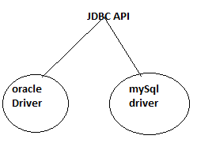

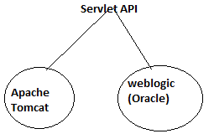

Servlet API acts as requirement specification to develop the web server which are implemented by the web server vendors.

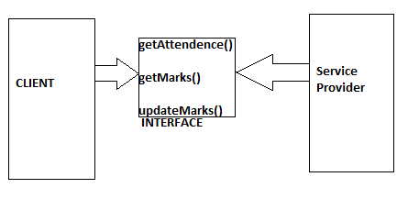

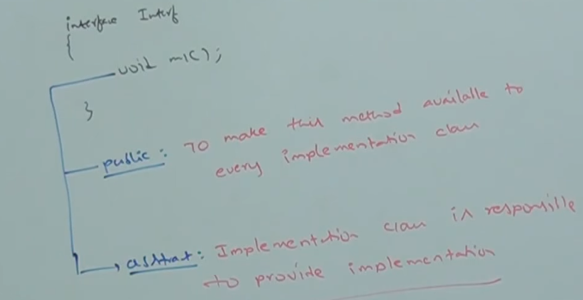

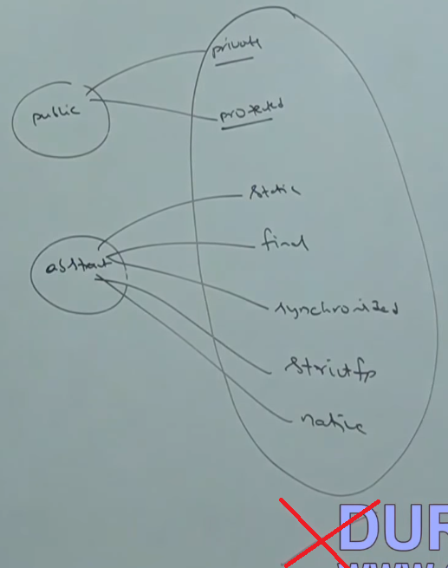

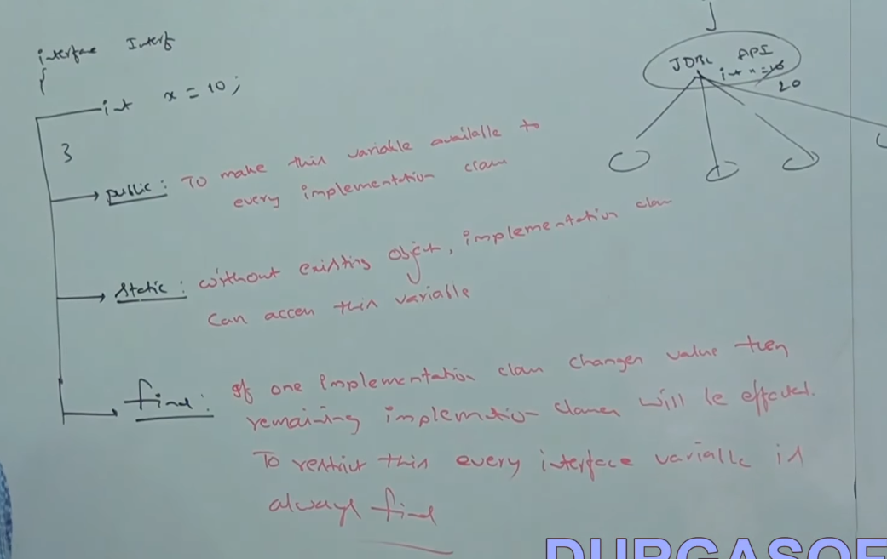

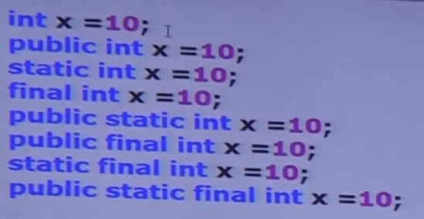

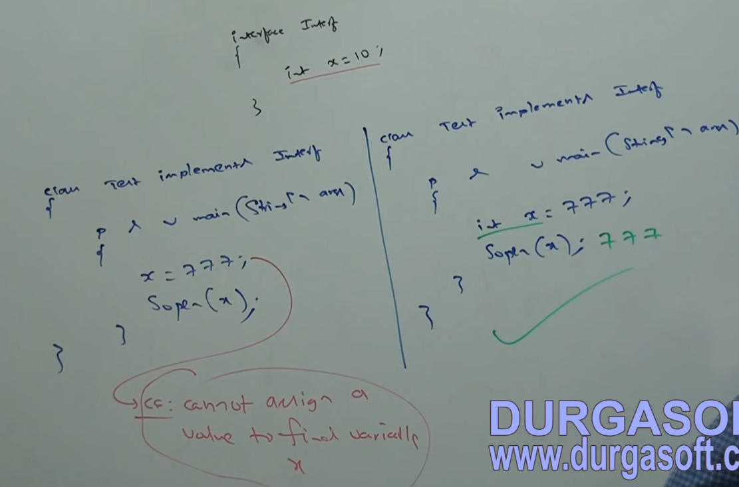

NOTE:

Case 1: If two interfaces have same method name and same return types then there will be no conflict in the class that is implementing it.

**interface** A {

**void** a();

}

**interface** B {

**void** a();

}

**class** C **implements** A, B {

@Override

**public** **void** a() {

**// NO CONFLICTS**

}

}

Case 2: If two interfaces have same method name and different primitive return types the it is impossible to implement both of the interfaces simultaneously.

Even by using different subclasses it will give compile time error as by using different class it is method overriding and in primitive data types different return types gives compile time error.

**interface** A {

**void** a();

}

**interface** B {

**int** a();

}

**class** C **implements** A, B {

**public** **void** a() {

// COMPILE TIME ERROR

}

}

***MARKER interface***

If the interface does not contain any method inside it and by implementing if our object will get some extra ability, such type of interface is called marker interface.

Example:

1. Serializable interface
2. Cloneable Interface
3. RandomAccess
4. SingleThreadModel

Internally JVM will provide the implementation.

JVM is provided this to reduce the complexity of programming and to make java language as simple as possible.

Question: Is it possible to create our own marker interface.

Yes, but customization of the JVM is required. Tomcat, Oracle, WebLogic(Here JVM is called WebRocket) provides their own JVM.

**Adapter class:** it is a simple java class that implements the interface with only empty implementations. Suppose an interface contains 1000 methods and if any class is implementing it then it must provide the implementations for all the methods. So, we use this trick and create a simple java class and make it implement that interface and provide the empty implementations of all the classes. So in future if any class extends it can override only the required method and provides its implementation.

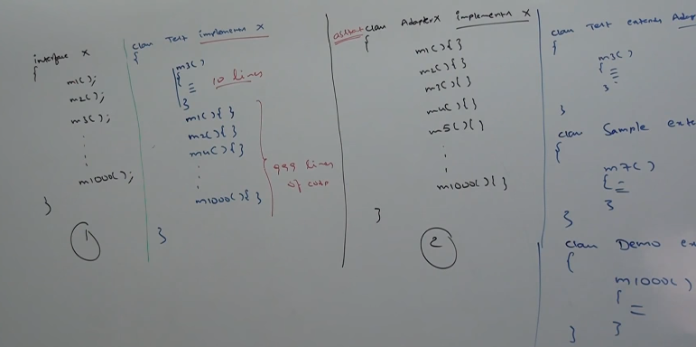

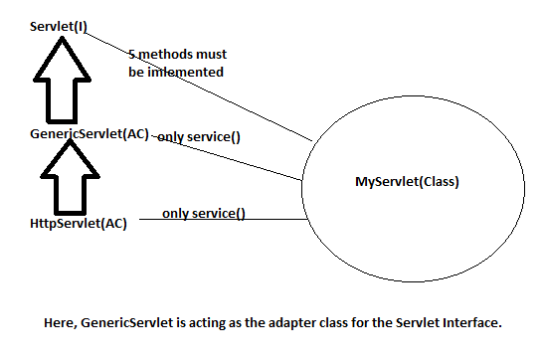

OVERRIDING

**class** Parent {

**public** **void** marry() {

System.*out*.println("Arrange Marriage");

}

}

**class** Child **extends** Parent {

**public** **void** marry() {

System.*out*.println("Love Marriage");

}

}

**public** **class** Test {

**public** **static** **void** main(String[] args) {

Parent p = **new** Parent();

p.marry(); //It will call the method from Parent class without any problem

Child c = **new** Child();

c.marry();//It will call the method from Child class without any problem

Parent p2 = **new** Child();

p2.marry();//At the compile time it will check whether the parent call contains marry()

}

}

**NOTE:::::Over-riding is called RUNTIME POLYMORPHISM, DYNAMIC POLYMORPHISM, LATE BINDING because the output is generated on the basis of runtime.**

As in the third case Parent p2=new child();, compiler will first check whether the parent class contain marry method or not and if it contains then it compiles with no problem **but the output generated is the over-riding method as JVM will check at the RUNTIME if the object created over-rides the marry() method or not.**

**\*NOTE 1::: IN over-riding method resolution is always taken care by JVM based on runtime object and hence it is called RUNTIME POLYMORPHISM, DYNAMIC POLYMORPHISM or LATE BINDING.**

**\*NOTE2::: While in overloading method all the things are taken by the compiler and hence it is called COMPILE-TIME POLYMORPHISM, STATIC POLYMORPHISM OR EARLY BINDING.**

**\*NOTE3::: When we over-ride static methods it seems like it is method over-riding but infact it is method hiding.**

All the rules for method over-riding are applicable to method hiding except one small but major difference. That is in over-riding the output is based on runtime object that has been created but in method hiding it is based on the reference from which you are calling the method.

Over-riding works only for methods and not for the variables.

**class** Parent {

**public** static **void** marry() {

System.*out*.println("Arrange Marriage");

}

}

**class** Child **extends** Parent {

**public** static **void** marry() {

System.*out*.println("Love Marriage");

}

}

**public** **class** Test {

**public** **static** **void** main(String[] args) {

Parent p = **new** Parent();

p.marry(); //parent marry() method will execute

Child c = **new** Child();

c.marry();//child marry() method will execute

Parent p2 = **new** Child();

p2.marry(); //parent marry() method will execute while in over-riding child method will be called.

**In case of var arg method:**

You can over-ride var-arg method with the var-arg method only otherwise it will work like overloading.

**class** Parent {

**public** **void** marry(int…x) {

System.*out*.println("Arrange Marriage");

}

}

**class** Child **extends** Parent {

**public** **void** marry() {

System.*out*.println("Love Marriage");

}

}

**public** **class** Test {

**public** **static** **void** main(String[] args) {

Parent p = **new** Parent();

p.marry(); //parent marry() method will execute

Child c = **new** Child();

c.marry();//child marry() method will execute

Parent p2 = **new** Child();

p2.marry(); //parent marry() method will execute while in over-riding child method will be called.

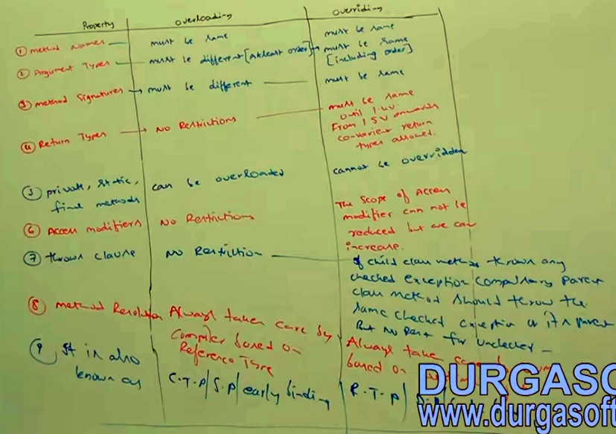

**Overloading:**

**CASE: 1**

**class** Sample {  
 **public void** a(**int** a) {  
 System.***out***.println(**"int "** + a);  
 }  
  
  
  **public void** a(**float** a) {  
 System.***out***.println(**"float "** + a);  
  
 }

**public static void** main(String[] args) {  
  
 Sample sample = **new** Sample();  
 sample.a(10); *// int 10* sample.a(10f); *// float 10.0* sample.a(**'a'**); *// int 97* sample.a(10l); *// float 10.0*

sample.a(10.0); *// compliation error*

}}

In sample.a(**'a'**), compile time error will not come directly. First it will check whether the method with char argument in present or not.

If char argument method in not present then it will do promotion first i.e,

**Char -> int -> long -> float -> double**

As 10.0 is double, first jvm will check method with double argument. As there is no method will double argument **and promotion of double cannot be done.**

**CASE: 2**

**class** Sample {  
 **public void** a(String a) {  
 System.***out***.println(**"String version"**);  
 }  
  
  
 **public void** a(Object a) {  
 System.***out***.println(**"Object version"**);  
  
 }  
  
 **public static void** main(String[] args) {  
  
 Sample sample = **new** Sample();  
 sample.a(**new** Object()); *// Object version* sample.a(**"hello"**); *// String version* sample.a(**null**); *// String version* }}

NOTE: In the above while resolving the overloaded method child method will get the higher precedence than the parent one, hence the sample.a(**null**) results in String version.

**CASE: 3**

**class** Sample {  
 **public void** a(String a) {  
 System.***out***.println(**"String version"**);  
 }  
  
  
 **public void** a(StringBuffer a) {  
 System.***out***.println(**"StringBuffer version"**);  
  
 }  
  
 **public static void** main(String[] args) {  
  
 Sample sample = **new** Sample();  
 sample.a(**"hello"**); *// String version* sample.a(**new** StringBuffer(**"hello"**)); *// StringBuffer version* sample.a(**null**); //compilation error as String and StringBuffer are siblings so both have same precedence.

**// reference to method a() is ambiguous.**  
 }  
  
}

**CASE: 4**

**class** Sample {  
 **public void** a(**int** i, **float** f) {  
 System.***out***.println(**"int-float version"**);  
 }  
  
  
 **public void** a(**float** f, **int** i) {  
 System.***out***.println(**"float-int version"**);  
  
 }  
  
 **public static void** main(String[] args) {  
  
 Sample sample = **new** Sample();  
 sample.a(10, 10.5f); *// int-float version* sample.a(10.5f, 10); *// float-int version* sample.a(10, 10); // compilation error

**// reference to method a() is ambiguous.**

}}

**NOTE:** In this case JVM has not fixed pattern to look the parameters i.e, jvm does not look parameters from left to right or right to left. If it used to look from left to right then the answer would be int-float version and if right to left then the answer would be float-int version. As first 10 can also be promoted to float and second 10 can also be promoted to float, therefore ambiguity problem will arise.

**CASE: 5**

**class** Sample {  
 **public void** a(**int** i) {  
 System.***out***.println(**"int version"**);  
 }  
  
  
 **public void** a(**int**... i) {  
 System.***out***.println(**"var-arg version"**);  
  
 }  
  
 **public static void** main(String[] args) {  
  
 Sample sample = **new** Sample();  
 sample.a(); *// var-arg version* sample.a(10, 20); *// var-arg version* sample.a(10); *// int version* }  
  
}

NOTE: var-arg method will get the chance only when no other method matches.

**CASE: 6**

**class** Animal {  
}  
  
**class** Monkey **extends** Animal {  
  
}  
  
**class** Test {  
  
 **public void** m1(Animal a) {  
 System.***out***.println(**"Animal"**);  
 }  
  
 **public void** m1(Monkey m) {  
 System.***out***.println(**"Monkey"**);  
 }  
 **public static void** main(String[] args) {  
 Test t = **new** Test();  
 Animal animal = **new** Animal();  
 Monkey monkey = **new** Monkey();  
 t.m1(animal); *// Animal* t.m1(monkey);*// Monkey* Animal animal1 = **new** Monkey();  
 t.m1(animal1); *// Animal* }}

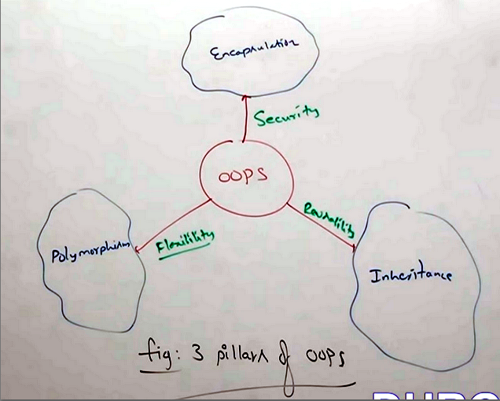

**CO-VARIANT:**

Inover-riding the return type must be same until 1.4v but from 1.5v onwards concept of co-variant return types came in which return type can be different.

**But this concept works if the return type is a Class and not any primitive data-type.**

Class A

{

public **Number** method()

{ return 0;}

Class B extends A

{

public **Integer** method()

{ return 0;}

}

In over-riding the following modifiers won’t keep any restrictions.

1. Synchronized
2. Native
3. StrictFp

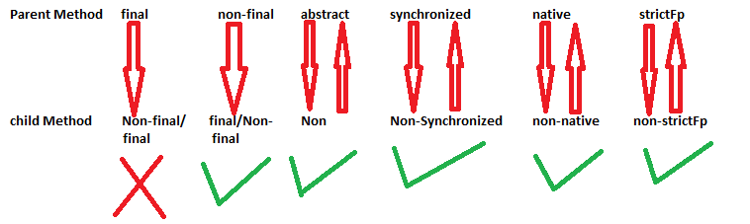

**SCOPE ORDER:**

Public > protected > default > private

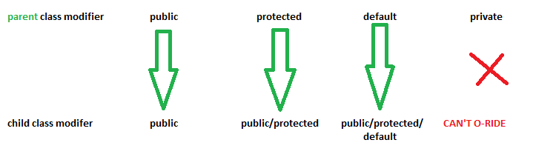

**NOTE:: If child class method throws any CHECKED EXCEPTION then its parent class must throw the same CHECKED EXCEPTION or its parent otherwise we will get compile time error but there are no restrictions for UNCHECKED EXCEPTIONS.**

**class** Parent {

**public** **void** marry()**throws** Exception {}

}

**class** Child **extends** Parent {

**public** **void** marry(){}//Compiles fine

}

**class** Parent {

**public** **void** marry(){}

}

**class** Child **extends** Parent {

**public** **void** marry()**throws** Exception{} //wrong, child class method throws checked exception

}

1. *A class is called tightly Encapsulated if and only if all the data* *members(Variables) in it are private.*
2. Data hiding is nothing but hiding of data members(variables) i.e, by making them private we can achieve data hiding. For example

private String name;

1. Abstraction is showing only import features to an end user ie, hiding internal methods. Only after authentication and validation an end user can further proceed. In java Interface, abstract classes are used to achieve this.
2. Encapsulation is nothing but data hiding+Abstraction. It means wrapping up of all the data members and methods(behaviour) in a single unit

Class A

{

Private String name; //This is achieving data hiding

public String getName() //this is achieving abstraction

{

//Validation

return name;

}

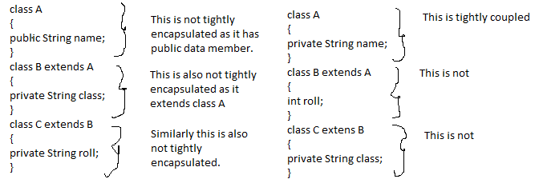

Note: If parent class is not tighty encapsulated then child class is also not tightly encapsulated.

1. Is-A relationship can be achieved by the extends keyword. It gives the user the functionality of reusability i.e, write once in a parent class and use that in child class. Is-A relationshipis also known as inheritance.
2. The Exceptions that are checked by the compiler for the smooth functioning at runtime are called checked exceptions.

JDK,JRE,JVM

JDK: to develop as well as run the program JDK is used. For developers JDK is required.

JRE: Required only to run the java application. Clients use it.

JVM: It is an interpreter. It runs the program line by line.

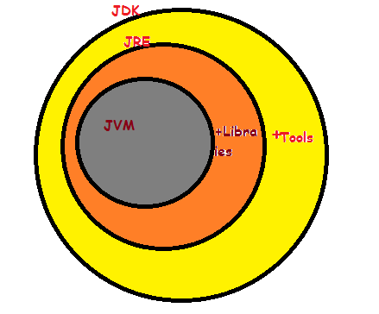

**Composition :** Since Engine is-part-of Car, the relationship between them is Composition. Here is how they are implemented between Java classes.

**public** **class** **Car** {

//final will make sure engine is initialized

**private** **final** Engine engine;

**public** **Car**(){

engine = **new** Engine();

}

}

**class** **Engine** {

**private** String type;

}

**Aggregation :** Since Organization has Person as employees, the relationship between them is Aggregation. Here is how they look like in terms of Java classes

**public** **class** **Organization** {

**private** List employees;

}

**public** **class** **Person** {

**private** String name;

}

About type casting!

1. Through type casting we are not creating any object but we are creating a new reference to that object.
2. Example String s=new String(“Tanuj”); In this we are creating a string object with reference s. If we want to type cast this string in to object class then the syntax will be as follows:-

Object o=(Object)s; Here new object is not created but the new reference is created to that string object.

Or

Object o=new String(“Tanuj”);

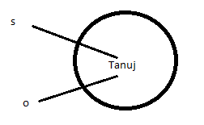

1. Singleton class is that class whose only one object can be made. For ex. Runtime, ServiceLocator.
2. Benefit of singleton class is that if the requirement is same then we don’t have to create another class but we can utilize the objects of that singleton class. It improves performance and memory utilization.
3. Runtime class is used to communicate with the JVM. Runtime r1=Runtime.getRuntime();

Runtime r2=Runtime.getRuntime();

.

.

Runtime r1=Runtime.getRuntime();

In the above the object is created only first time. References r2,r3,…rn will reuse that object.

1. We can create our own singleton class by using private constructor,private static variable and a public factory method.

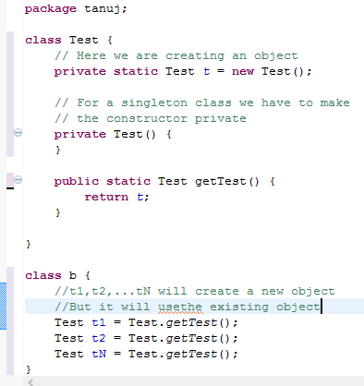

Approach 2;

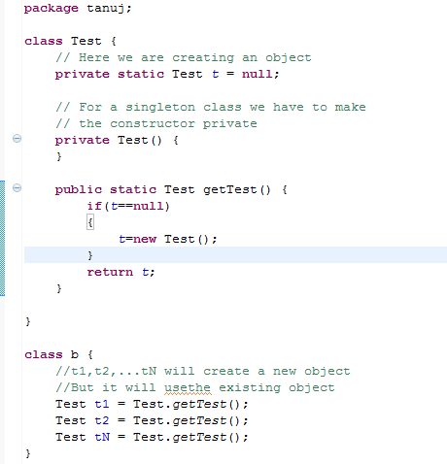

NOTE: Main purpose of private constructor is to create singleton class.

Q. In the above the class is not final but we are not allowed to create child classes. How is it possible?

Ans. By using private constructor.

Static control Flow:

1. Identification of static variables from top to bottom.
2. Execution of static variable assignments(static int=4) and execution of static block.
3. Execution of main method.

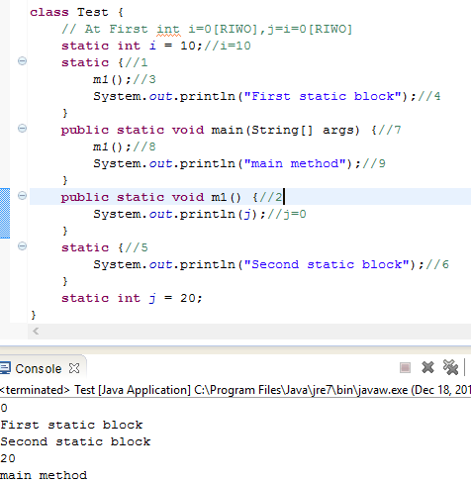

[RIWO]=Read indirectly write only

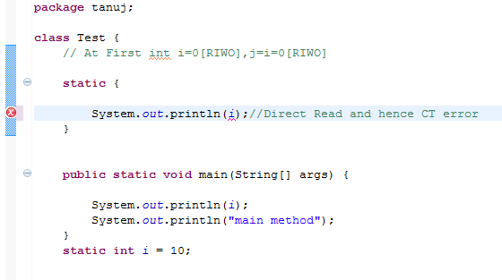

At the time of java class loading the corresponding native libraries should be loaded hence we have to define this activity inside static block.

class Test

{  
static

{  
System.loadLibrary(“native library path”);

}

}

**Instance control flow:**

Static control flow is a one tome activity but instance control flow is not one time activity and it will be performed for every object creation.

1. identification of instance members from top to bottom.

2. Execution of instance variable assignments and instance blocks from top to bottom.

3. execution of constructor.

**class** Test {

**int** i=10;

{

m1();

System.*out*.println("First Instance block");

}

Test()

{

System.*out*.println("Constructor");

}

**public** **static** **void** main(String[] args) {

Test t=**new** Test();

System.*out*.println("Main method");

Test t1=**new** Test();

}

**public** **void** m1()

{

System.*out*.println(j);

}

{

System.*out*.println("Second instance block");

}

**int** j=20;

}

0

First Instance block

Second instance block

Constructor

Main method

0

First Instance block

Second instance block

Constructor

**class** Test {

**int** i=10;

{

m1();

System.*out*.println("First Instance block of parent");

}

Test()

{

System.*out*.println("Parent class Constructor");

}

**public** **static** **void** main(String[] args) {

Test t=**new** Test();

System.*out*.println("Main method");

}

**public** **void** m1()

{

System.*out*.println(j);

}

**int** j=20;

}

**class** Child **extends** Test

{

**int** x=10;

{

m1();

System.*out*.println("First Instance block of child class");

}

Child()

{

System.*out*.println("Child class Constructor");

}

**public** **static** **void** main(String[] args) {

Child t=**new** Child();

System.*out*.println("Main method of child class");

}

**public** **void** m1()

{

System.*out*.println(y);

}

**int** y=20;

}

0

First Instance block of parent

Parent class Constructor

0

First Instance block of child class

Child class Constructor

Main method of child class

Coupling:

1. The degree of dependencies between the components is called coupling.
2. If dependency is more then it is considered as tightly coupling.
3. Tightly coupled example:

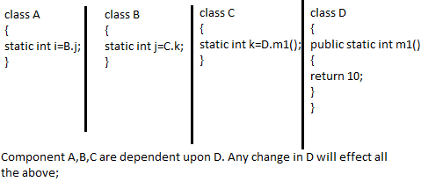

1. The practice of tight coupling is worst. We must follow low coupling and high cohesion.
2. If the component have a set of well-defined specific functionalities then it is known to follow high cohesion. High cohesion is always a good practice.

***MAIN METHOD:***

1. In JVM there is a predefined prototype of main method i.e, public static void main(String args[]). Hence JVM always searches for main method at runtime.
2. It is public so that JVM can call it from anywhere.
3. It is static as JVM call it without making its object for the better performance.
4. It is void as if it will return anything then it will be of no use to JVM.
5. String args[] is a command line argument.

***Note: final synchronized strictfp public static void main(String args[]) is valid.***

1. Overloading is applicable for main method but JVM will always call psvm(String args[]).
2. In 1.7 version of java main() method is mandatory.
3. 12 types of access modifiers:

* public
* private
* protected
* <default>
* static
* final
* abstract
* synchronized
* native
* strictfp
* transient
* volatile

Note: there are no access specifier in java.

1. public, <default>, final, abstract, strictfp are the only access modifiers that can be used with outer class.

Ques. What is the difference between & and &&.

Ans. If we use & under if condition than all the arguments will operates irrespective of one false hence wasting the time.

For eg.

if(argument1 ***&*** argument2)

{

{

else

{

}

In the above both arguments will be operated even if argument1 is false

if(argument1 ***&&*** argument2)

{

}

else

{

}

In the above argument2 will be operated if only it is required.

Hence short circuit operators increases performance.

NOTE: && and || are called short circuit operators.

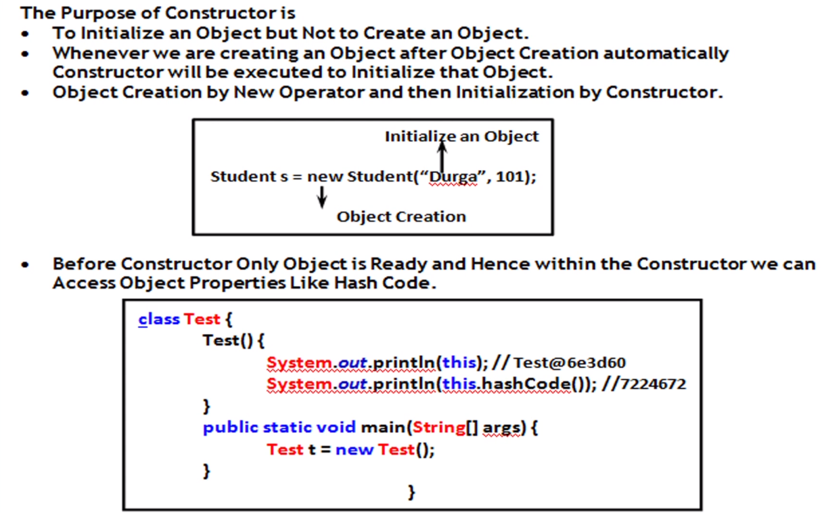

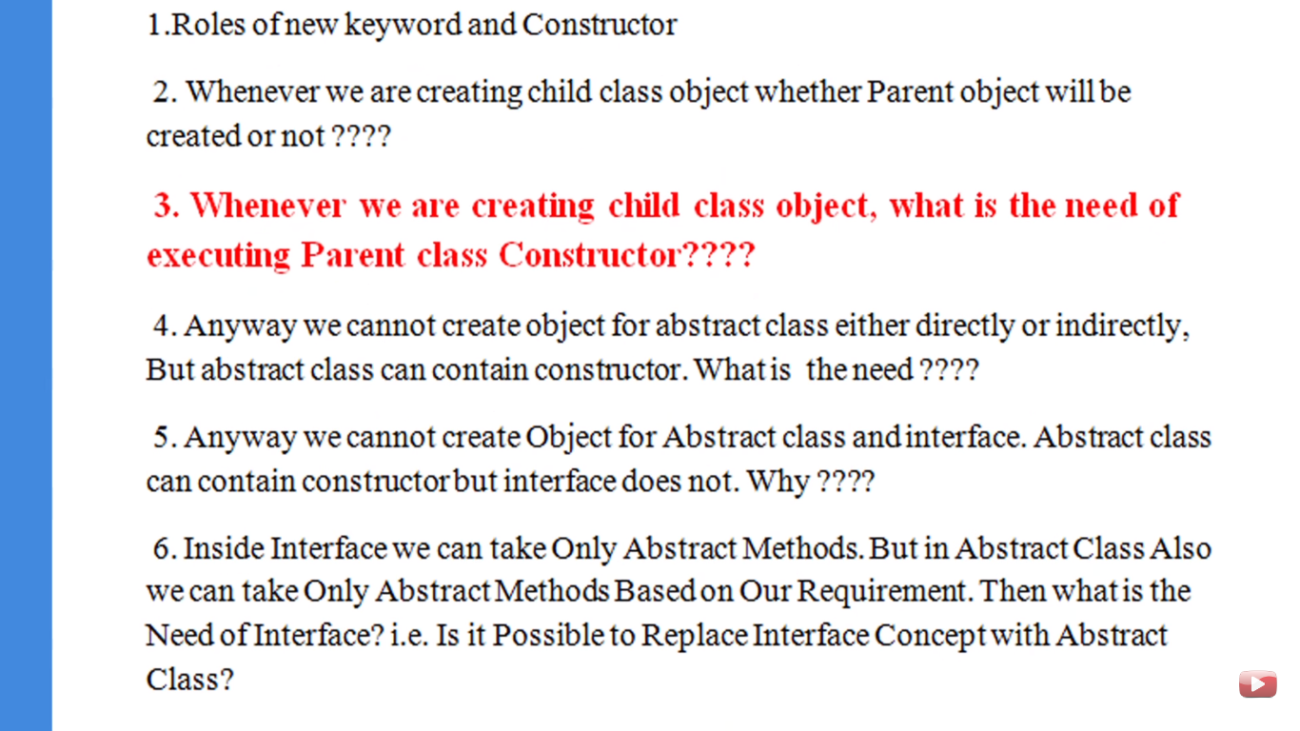

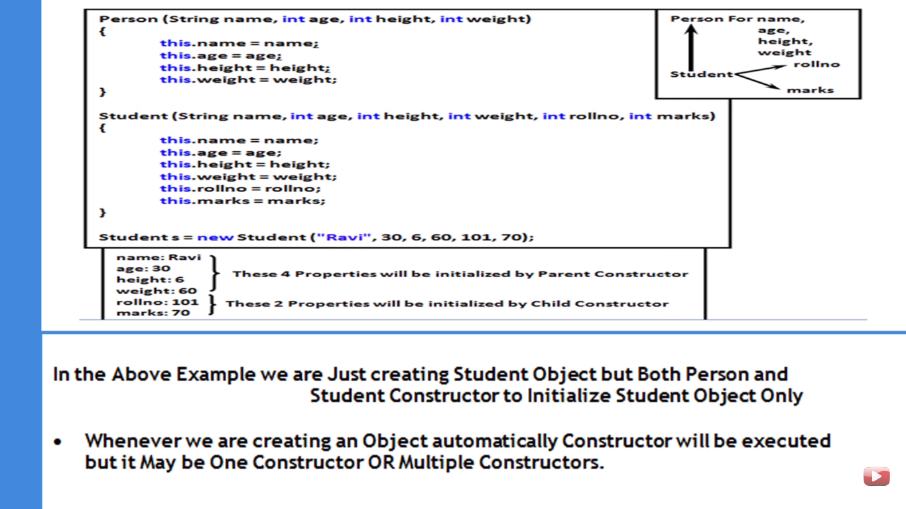

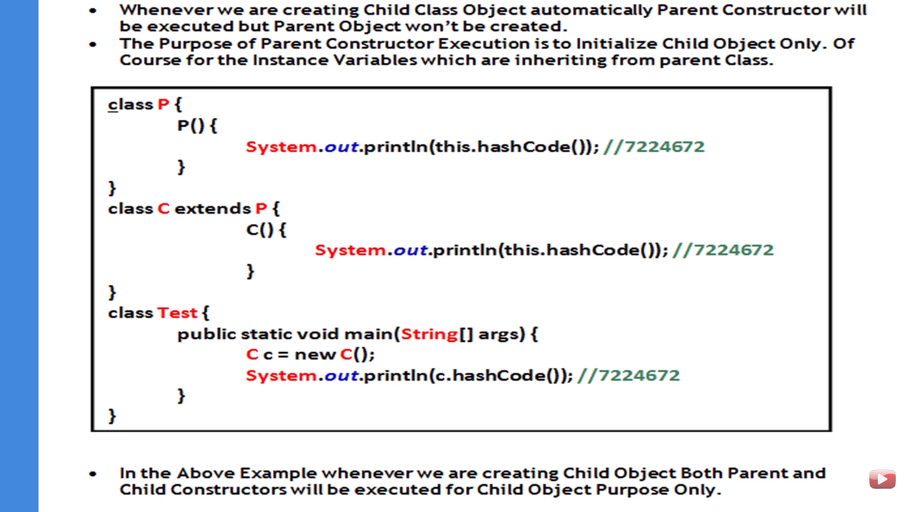

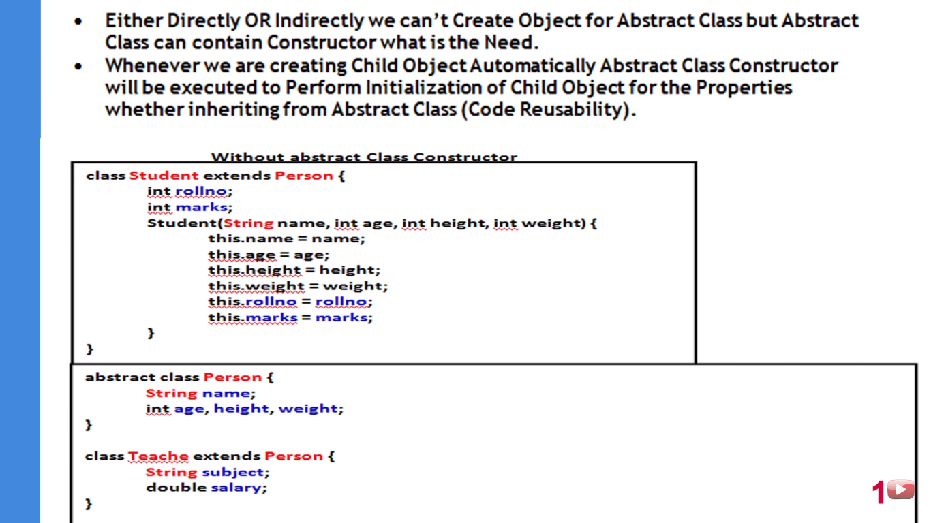

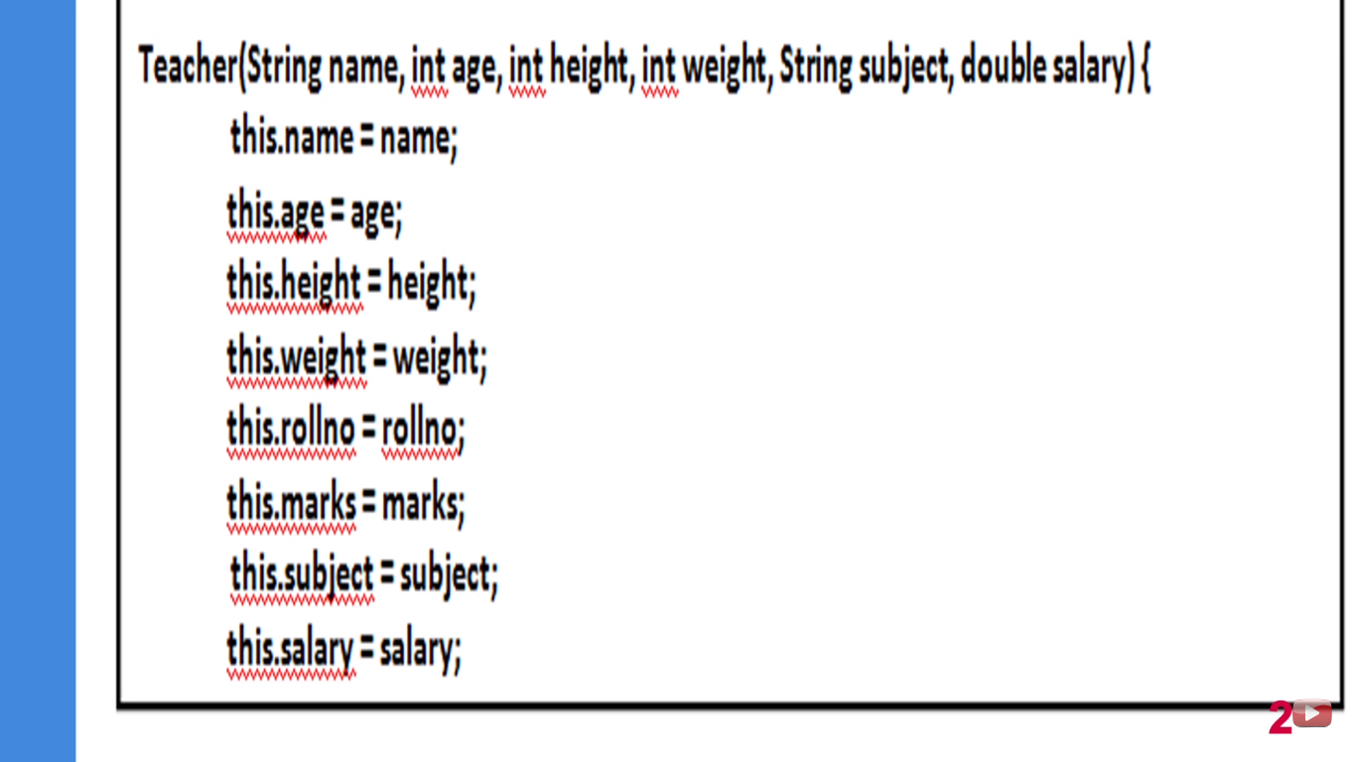

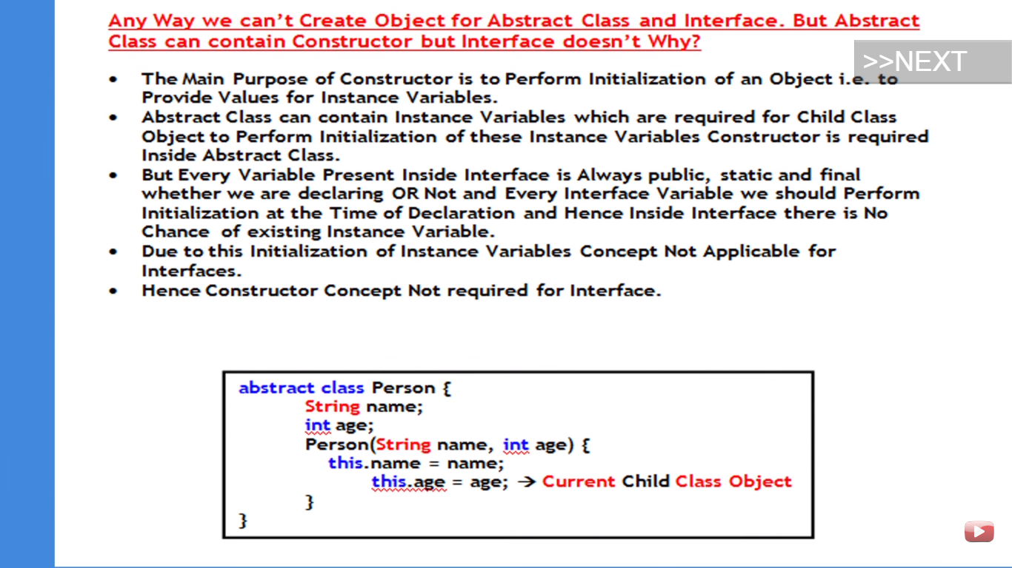

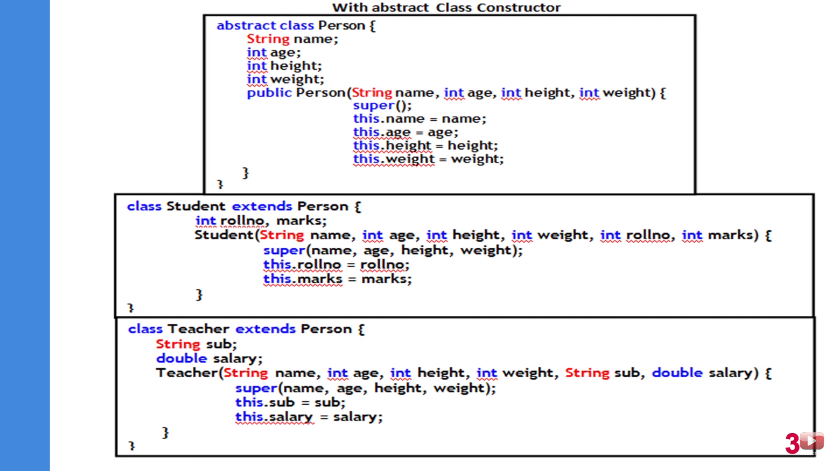

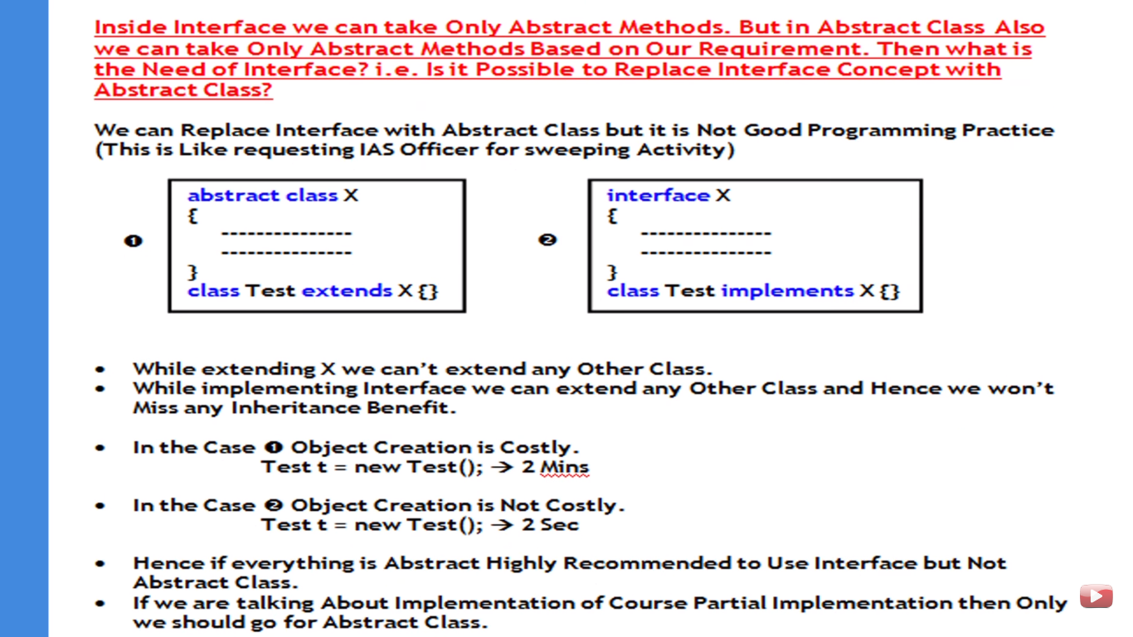

**.equals() METHOD:::**

In object class it is applied for reference comparison.

But in all the collection classes, wrapper classes, String class, it is used for content comparison. So it is highly recommended to override .equals() method in our class also for content comparison.

**import** java.lang.reflect.Method;

**public** **class** Student {

**public** **static** **void** main(String[] args)**throws** Exception {

Class o=Class.*forName*("java.lang.Object");

Method[] m=o.getDeclaredMethods();

**for**(Method m1:m)

{

System.*out*.println(m1.getName());

System.*out*.println(m1.toString());

}

}

}

**Output::::::**

**finalize**

**wait**

**wait**

**wait**

**equals**

**toString**

**hashCode**

**getClass**

**clone**

**notify**

**notifyAll**

**registerNatives**

**protected void java.lang.Object.finalize() throws java.lang.Throwable**

**public final void java.lang.Object.wait() throws java.lang.InterruptedException**

**public final void java.lang.Object.wait(long,int) throws java.lang.InterruptedException**

**public final native void java.lang.Object.wait(long) throws java.lang.InterruptedException**

**public boolean java.lang.Object.equals(java.lang.Object)**

**public java.lang.String java.lang.Object.toString()**

**public native int java.lang.Object.hashCode()**

**public final native java.lang.Class java.lang.Object.getClass()**

**protected native java.lang.Object java.lang.Object.clone() throws java.lang.CloneNotSupportedException**

**public final native void java.lang.Object.notify()**

**public final native void java.lang.Object.notifyAll()**

**private static native void java.lang.Object.registerNatives()**

There are several hashing related data structures in java like HashSet, HashMap, HashTable etc.

In these data structures JVM uses hashcode to save these data.

Hashing has the complexity of O(1).

For every object in the java a unique number is generated by JVM which is called hashcode. Hashcode do not represent the address of the object. JVM will use hashcode while saving objects into hashing related data structures. The main advantage of saving objects based on hashcode is search operation will become easy(the most powerful search algorithm up to today is HASHING).

If we do not override the hashcode() method then the hashcode() method of the Object class will be used i.e,

Public native int hashCode()

If you are giving the chance to Object class hashCode() method, it will generate hashCode based on the address of the object. It doesn’t mean hashcode represents address of the object.

Based on your requirement, we can override hashcode method in our class to generate our own hashcode which is not dependent on the address of the object.

Overriding hashCode() method is said to be proper if and only if for every object we have to generate a unique number as hashcode.

**IMPROPER WAY: As all the object will have 100 hashcode and the searching will fail.**

**public** **class** HashCode

{

**public** **int** hashCode() {

**return** 100;

}

**public** **static** **void** main(String[] args) {

hashco h=**new** hashco();

}

}

**PROPER WAY:**

**public** **class** HashCode

{

**public** **int** hashCode() {

**return** rollNumber;

}

**public** **static** **void** main(String[] args) {

HashCode h=**new** HashCode();

}

}

toString() Vs hashCode()

if we are giving the chance to Object class toString method it will internally calls hashCode() method.

If we are overriding toString method then our toString method may not call hashCode() method.

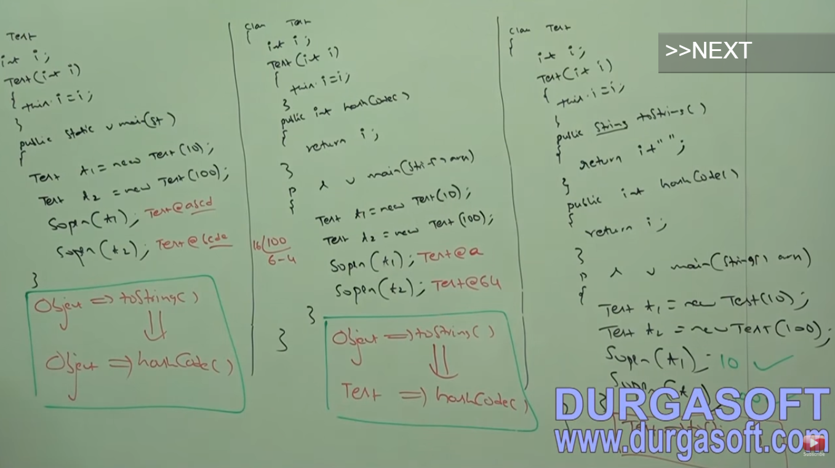

**Object class toString():**

@Override  
**public** String toString() {  
 **return** getClass().getName() + **"@"** + Integer.*toHexString*(hashCode());  
}

Hence -> **class Name + @ + hashcode = Test@10**

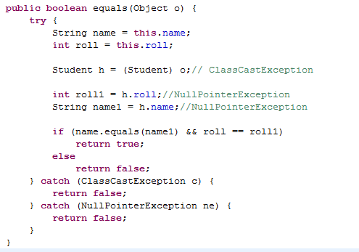

**More Simplified Version of equals method**

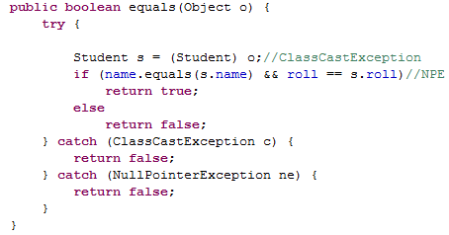

Above is the correct way of overriding the equals() method, as ClassCastException and NullPointerException can arise.

For example, s1.equals(null) can lead to NPE

s1.equals(“Tanuj”) can lead to CCE as both the objects are heterogeneous

**public** **class** Student {

**int** roll;

String name;

Student(String name, **int** roll) {

**this**.roll = roll;

**this**.name = name;

}

**public** **boolean** equals(Object o) {

**if**(o **instanceof** Student)

{

Student s = (Student) o;

**if** (name.equals(s.name) && roll == s.roll)

**return** **true**;

}

**else**

{

**return** **false**;

}

**return** **false**;

}

**public** **static** **void** main(String[] args) {

Student h = **new** Student("Tanuj", 10);

Student h1 = **new** Student("Tanuj", 10);

System.*out*.println(h.equals(h1)); // HashCode@a

}

}

**Wrapper Class::::**

When we have some primitive data and we have to project it as an object then we use the concept of wrapper class. The main objective of a wrapper class are:

1. To wrap primitive into object form so the it can be handled just like object.
2. To define several utilities methods for the primitives.

**Constructors::**

Almost all wrapper classes contains two constructors, one can take primitive as argument and the other can take String as the argument.

Integer i=new Integer(10);

Integer i=new Integer(“10”);

Integer i=Integer.valueOf(10);

Integer i=Integer.valueOf(“10”);

Integer i=Integer.valueOf(“10”,2); //For binary

**ALLOWED BASE IS 2 TO 36**

**public static wrapper valueOf(String s);**

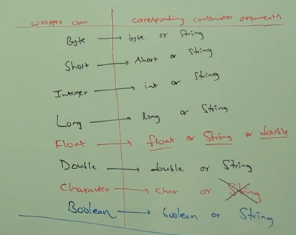

**parseXXX() method:::: i.e parseInt(), parseFloat(), parseDouble()**

I have String and I want to convert it into primitive.

So this method is used for converting the String into the primitive.

**public static primitive parseXXX(String s);**

Every wrapper class contains this method except the Character class as we cannot pass string as an argument in Character constructor

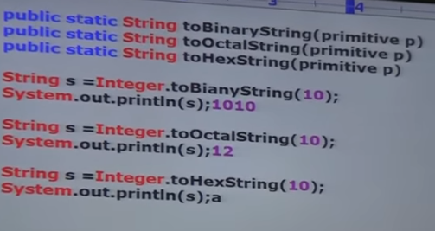

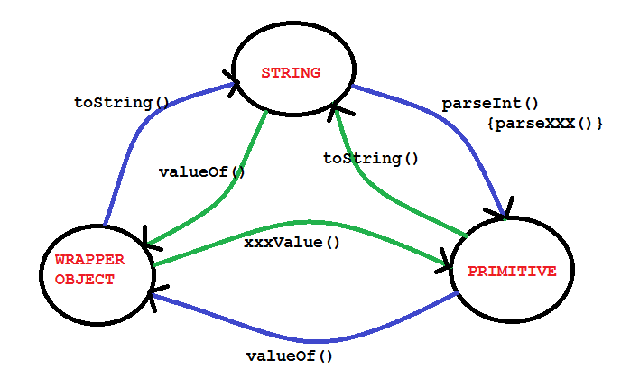

**Void is the class representation of void.**

**Autoboxing:**

It is the automatic conversion of primitive to wrapper object by compiler is called autoboxing.

**Example::**

Integer i=10;

In the above compiler converts int to Integer automatically.

Internally the compliler will use :::

Integer i=Integer.valueOf(10);

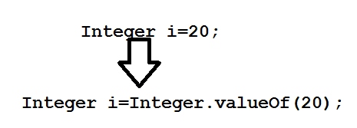

So internally it is implemented by valueOf() method.

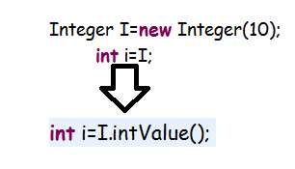

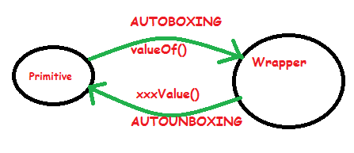

**public** **class** Student {

**static** Integer *I* = 10;// AUTOBOXING Integer.ValueOf(10)

**public** **static** **void** main(String[] args) {

**int** i = *I*;// AUTO-UN-BOXING I.intValue()

*m*(i);

}

**public** **static** **void** m(Integer k)// AUTO-BOXING

{

**int** m = k;// AUTO-UN-BOXING

System.*out*.println(m);

}

}

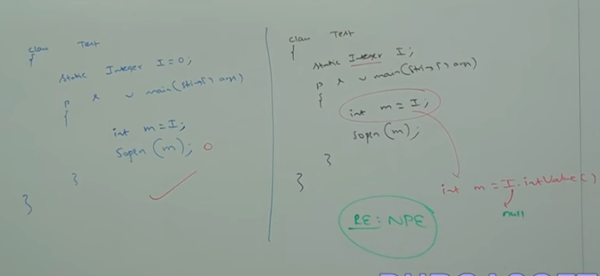

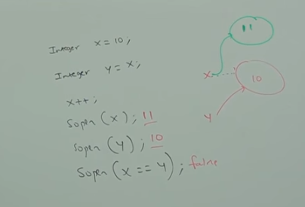

All wrapper class are immutable, if we are trying to perform any changes with those changes a new object will be created.

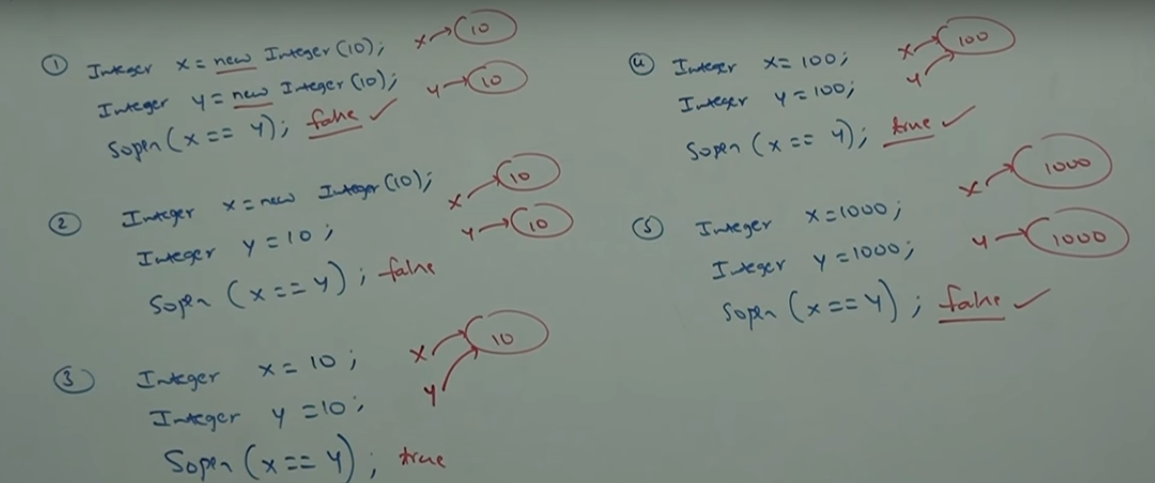when wrapper class are created, the SUN have defined the buffer for that wrapper class as defined in the below diagram.

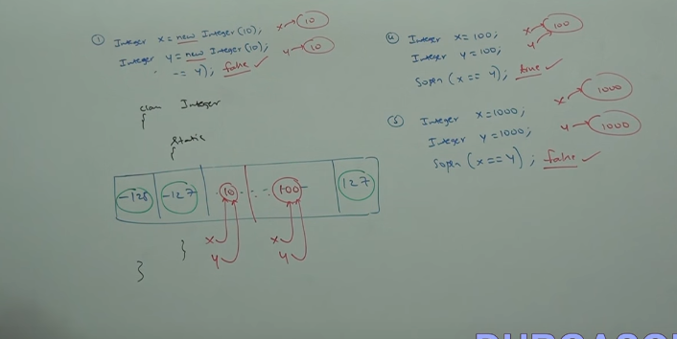

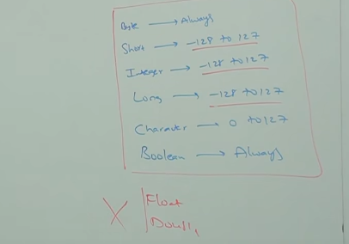

AUTOBOXING VS WIDENING

**public** **class** Student {

**public** **void** m(Integer I)

{

System.*out*.println("AUTOBOXING");

}

**public** **void** m(**long** l)

{

System.*out*.println("WIDENING");

}

**public** **static** **void** main(String[] args) {

Student s=**new** Student();

**int** i=10;

s.m(i);

}}

Output::::

WIDENING

Widening dominates Autoboxing as widening came since JAVA 1.0v.

In java autoboxing followed by the widening is accepted but widening followed by autoboxing is not accepted.

Long l=10; //It is not valid

Object o=10;// It is valid as it is the autoboxing followed by the widening

**int ====AUTOBOXING====🡺 Integer ====WIDENING====🡺 Object**